Project Title: Air Quality Monitoring

Phase 2: **INNOVATION**

SENSORS :

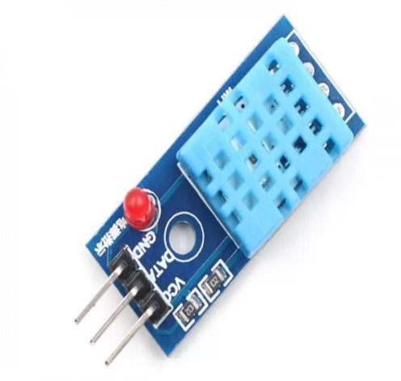

1. Temperature and Humidity sensors.

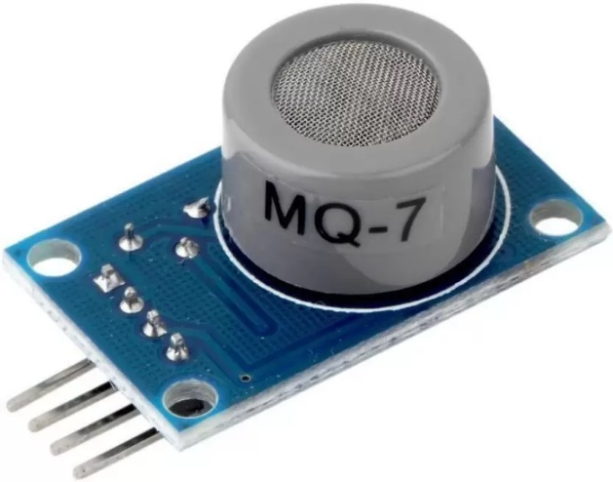

1. Gas Sensor

Definition For Sensors:

Humidity Sensor:

A humidity sensor is an electronic device that measures the humidity in its environment and converts its findings into a corresponding electrical signal. Humidity sensors vary widely in size and fu | A humidity sensor is an electronic device that measures the humidity in its environment and converts its findings into a corresponding electrical signal.

Temperature Sensor:

A temperature sensor is a device used to measure temperature. This can be air temperature, liquid temperature or the temperature of solid matter.

Gas Sensor:

Gas Sensor is the core of the gas detection system and is usually installed in the detection head. Essentially, a gas sensor is a converter that converts a certain gas volume fraction into a corresponding electrical signal.

STEPS FOR FLOWCHART:

1. Define the Purpose:

- Clearly state the purpose of the air quality monitoring process. This could be to measure and record air pollutants, ensure compliance with regulations, or provide real-time air quality information.

2. Start/End:

- Begin your flowchart with a "Start" symbol, typically represented by an oval or a rectangle with rounded corners.

- End the flowchart with an "End" symbol, which is also represented by an oval or a rectangle with rounded corners.

3. Data Collection:

- Determine how data will be collected. This may involve various sensors, instruments, or monitoring stations.

- Use a symbol like a rectangle to represent data collection points.

4. Data Processing:

- Show how the collected data is processed. This may include data filtering, validation, and conversion.

- Use a rectangle with rounded corners to represent data processing steps.

5. Data Analysis:

-Illustrate the steps involved in analyzing the processed data. This may include calculations, comparisons, or statistical analysis.

- Use a diamond-shaped symbol to represent decision points in the analysis.

6. Reporting and Display:

- Depict how the air quality data is presented to users. This could involve visual displays, reports, or notifications.

- Use a rectangle to represent reporting and display steps.

7. Data Storage:

- Show where the data is stored for future reference and analysis. This may involve databases or data repositories.

- Use a cylinder-shaped symbol to represent data storage.

8. Alarm Thresholds:

- If applicable, indicate how alarm thresholds are set and monitored for abnormal air quality conditions.

- Use another decision point (diamond-shaped symbol) to represent threshold checks.

9. Data Transmission:

- Indicate how the air quality data is transmitted to relevant stakeholders, which may include government agencies, the public, or environmental organizations.

- Use an arrow to show the flow of data transmission.

10. Regulatory Compliance:

- If applicable, include steps for ensuring compliance with air quality regulations and standards.

- Use decision points to represent compliance checks.

11. Maintenance and Calibration:

- Show how the monitoring equipment is maintained and calibrated regularly to ensure accurate measurements.

- Use rectangles or other symbols to represent maintenance and calibration activities.

12. Feedback Loop:

- If necessary, illustrate how the monitoring process incorporates feedback to improve data accuracy and reliability.

- Use arrows to represent feedback loops within the flowchart.

13. Documentation:

- Include a step for documenting the monitoring process, including procedures, data records, and reports.

- Use a rectangle to represent documentation.

14. Review and Validation:

- Show steps for reviewing and validating the collected data to ensure its accuracy and reliability.

- Use decision points to represent validation checks.

15. Continuous Monitoring:

- Indicate that the monitoring process is continuous and ongoing.

- Use a loop symbol or an arrow pointing back to a previous step to represent continuous monitoring.

16. End:

- Conclude the flowchart with an "End" symbol.

FLOWCHAT:

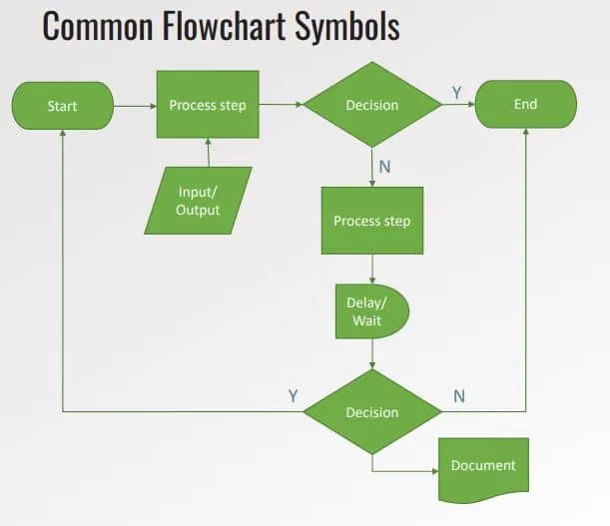

BLOCK DIAGRAM:

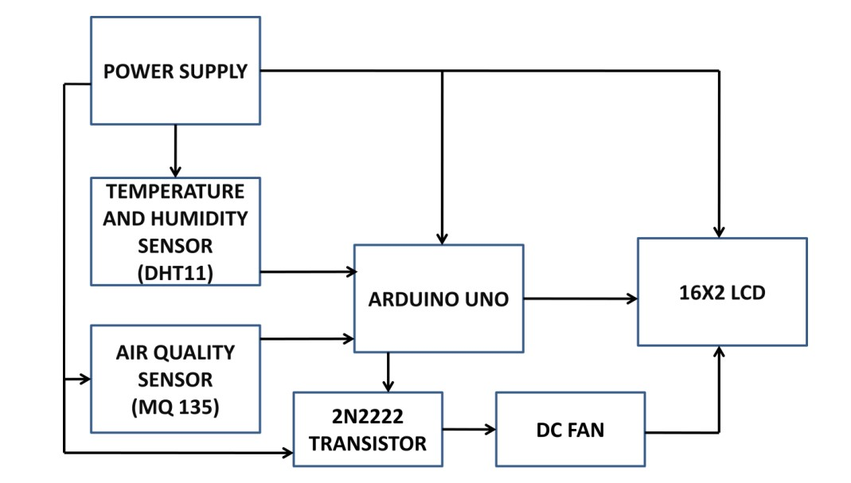

BLOCK DIAGRAM DISCRIPTION:

AURDUNIO UNO:

Arduino is an open source computer hardware and software company, project, and user community that designs and manufactures single-board microcontrollers and microcontroller kits for building digital devices and interactive objects that can sense and control objects in the physical world.

16X2 LCD Panel:

A liquid-crystal display (LCD) is a flat-panel display or other electronically modulated optical device that uses the light-modulating properties of liquid crystals Liquid crystals do not emit light directly, instead using a backlight or reflector .To produce images in colour or monochrome.[1]LCDs are available to display arbitrary images (as in a general-purpose computer display) or fixed images with low information content, which can be displayed or hidden, such as preset words, digits, and seven-segment displays.

Air Quality Sensor (MQ135):

Air quality click is suitable for detecting ammonia (NH3), nitrogen oxides (NOx) benzene, smoke, CO2 and other harmful or poisonous gases that impact air quality. The MQ-135 sensor unit has a sensor layer made of tin dioxide (SnO2), an inorganic compound which has lower conductivity in clean air than when polluting gases are present. To calibrate Air quality, use the on-board potentiometer to adjust the load resistance on the sensor circuit.

Temperature and humidity sensor (DHT11):

DHT11 digital temperature and humidity sensor is a composite Sensor contains a calibrated digital signal output of the temperature and humidity. Application of a dedicated digital modules collection technology and the temperature and humidity sensing technology, to ensure that the product has high reliability and excellent long-term stability. The sensor includes a resistive sense of wet components and an NTC temperature measurement devices, and connected with a high-performance 8-bit microcontroller.

Node MCU:

Node MCU is an open source IoT platform. It includes firmware which runs on the ESP8266 WiFi SoC from Espress if Systems, and hardware which is based on the ESP-12 module. The term "Node MCU" by default refers to the firmware rather than the development kits. The firmware uses the Lua scripting language. It is based on the e Lua project, and built on the Espress if Non OS SDK for ESP8266.

CIRCUIT DIAGRAM:

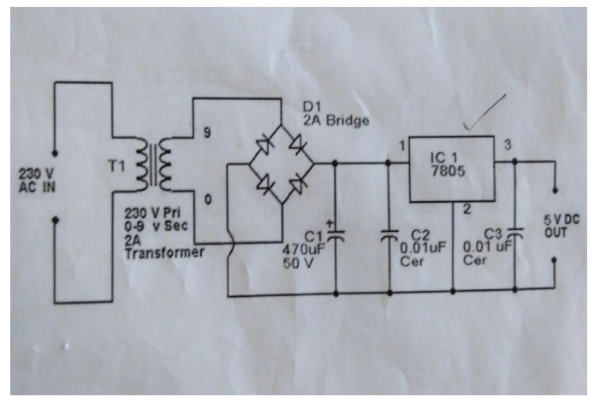

APPLICATION:

* Characterize the nature and severity of air pollution in the state.

* Measure air quality against the Ambient Air Quality Standards and determine attainment status.

* Identify trends in pollutant concentrations.

* Provide regularly updated air quality information.

* Determine levels of community exposure to harmful pollutants.